|  |  |
| --- | --- |
| ***April is National Child Abuse Prevention Month: Get involved!*** | ***#Unite4Kids*** |

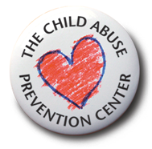



Family Strengthening Toolkit for   
Faith Communities during  
Child Abuse Prevention Month

Presented by:



**Overview:**

Every minute in America a child is reported abused or neglected. One in ten is born affected by drugs. One in five is sexually abused. Half a million children are reported abused in California each year. Every day in California at least one child dies as a result of abuse or neglect. Hearts are broken with each death, hopes are destroyed and the promise of a future is lost forever.  
  
In a Centers for Disease Control and Prevention sponsored study, Drs. Anda and Felleti discovered a strong correlation between childhood abuse and subsequent adult diseases including diabetes, obesity, depression, hepatitis, alcoholism, heart disease, fractures and suicide. For people who experienced four or more types of adverse childhood experiences (ACE’s), such as child abuse, the likelihood is increased by:

* 1220% that they will attempt suicide
* 1030% that they will be injection drug users
* 740% that they will be alcoholics
* 220% that they will smoke
* 160% that they will be severely obese

*Treatment costs 100 times more than prevention – and it is after the harm has occurred. Invest in your children, your family and your community with prevention. We aren’t searching for a cure. We have evidence-based methods that are proven to reduce child abuse cases by 96% among families served. Prevention works.*   
  
____________________________________________________________________________

**Talking points:**

* Children that are raised in loving and supportive environments are more likely to grow up and help create secure, healthy communities and be more productive, prosperous workers.
* Children that are raised in stable families do better academically, are shown to be more financially successful and contribute more to society.
* Abuse can be physical, sexual, emotional and neglect, sometimes all.
* Adverse Childhood Experiences (ACE’s) include things like child abuse (including physical, sexual, and emotional), neglect, parental stress, divorce, parental unemployment, parental mental illness or addiction. Greater than one in four people have experienced at least one ACE, and one in eight have experienced at least four or more ACEs during their childhood. The greater number of ACEs increases the risk of long-term adverse consequences. Reducing ACEs leads to positive long-term outcomes for children and communities, including lowering risk for serious health complications and helping children grow into more prosperous and productive adults.

____________________________________________________________________________

**Addressing Protective Factors:**

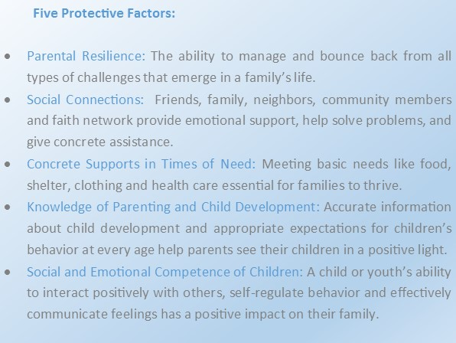

____________________________________________________________________________

**Tips and Activities:**

Faith based groups play a crucial role in reaching members and helping families and children thrive within the community. At risk families are more likely to seek guidance from spiritual leaders whom they trust. Spiritual leaders can use their voice to share important family strengthening messaging. Please consider implementing some of these tips throughout National Child Abuse Prevention Month and revisit them often throughout the year.

* Change social norms to support parents and positive parenting.
* Enhance parenting skills to promote healthy child development.
* Promote safety (home/car/sports) to prevent accidental childhood injuries.
* Raise awareness of child abuse and neglect by setting aside a day in April to observe Child Abuse Prevention Month and celebrate your community’s commitment to children and families.
* Train leaders and childcare volunteers to recognize the signs of abuse and neglect, to work with victims and their families, and to make appropriate referrals.
* Hold support groups and parent/guardian education events at your faith community’s facilities.
* Host an event for kids and families and provide trivia games, board games, card games, etc.
* Encourage members to introduce themselves to new members, new neighbors or new families at their children’s school.
* Publish a series of articles on child abuse prevention, awareness and reporting in your church newsletter or blog.
* Share information on child development, parental stress, and local community resources and supports for parents during counseling sessions with your members.
* Organize a “Baby Supplies” drive to collect diapers, formula, car seats, and other supplies for new parents and/or families in need.
* Invite The CAP Center’s experts to provide a training for your staff who work closely with youth on Mandated Child Abuse Reporting. This workshop teaches mandated reporters their legal responsibilities to report known or suspected child abuse and neglect in California, how to recognize indicators (red flags) of the different types of abuse and neglect, and how to make a Suspected Child Abuse Report. Contact us to schedule: (916) 244-1959.

____________________________________________________________________________

**Pinwheels for Prevention:**

* [**Pinwheels for Prevention**](http://www.thecapcenter.org/admin/upload/pinwheels%20for%20prevention%20ca%20order%20form.editable.pdf)is a national and local public awareness campaign that puts a new spin on prevention. The campaign uses community activities and public policies to prioritize prevention right from the start, making sure child abuse and neglect never occur. Since the launch of Pinwheels for Prevention in 2008, nearly 3 million pinwheels have been distributed and all 50 states have participated in the campaign. Let’s drastically increase this number in 2018 and bring wider awareness to the child abuse prevention! Can we count on your support?
* Participate in the [**Pinwheels for Prevention**](http://www.thecapcenter.org/admin/upload/pinwheels%20for%20prevention%20ca%20order%20form.editable.pdf) Campaign by planting a pinwheel garden or sharing the pinwheels with youth groups. Take a look at the [Pinwheels for Prevention toolkit here](http://www.thecapcenter.org/admin/upload/statewide%20pinwheels%20for%20prevention%20toolkit.ca.pdf) and [order Pinwheels for Prevention here](http://www.thecapcenter.org/admin/upload/pinwheels%20for%20prevention%20order%20form%20-%20california.xlsx) or visit [www.thecapcenter.org](http://www.thecapcenter.org).

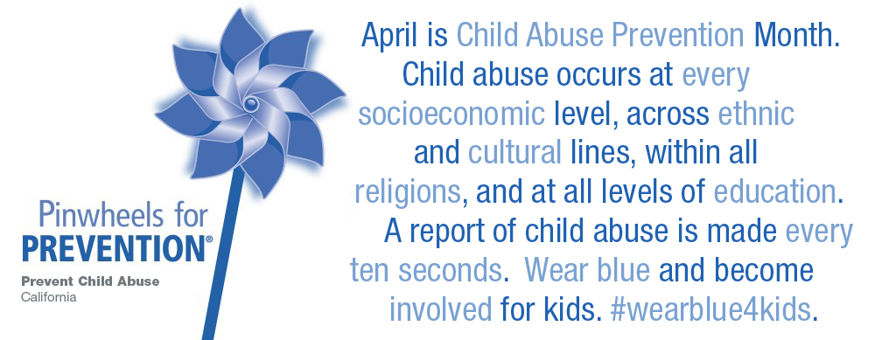

____________________________________________________________________________

**Sample Wear Blue Weekend News Release**:

FOR IMMEDIATE RELEASE: (DATE)   
CONTACT: (INSERT NAME, PHONE AND E-MAIL)

California WearBlue4Kids Faith Initiative Celebrated During Child Abuse Prevention Month:

April 1-3, 2022 — In April 2022, The Child Abuse Prevention (CAP) Center asks California’s faith community to work hand-in-hand with prevention efforts to raise awareness of child abuse and the importance of preventing abuse before it occurs. “The CAP Center is including WearBlue4Kids for faith communities in our statewide program for Child Abuse Prevention Month in April,” said Sheila Boxley, President & CEO of The CAP Center. “We are encouraging places of worship to share strategies to strengthen families during April and WearBlue4Kids during wear blue weekend to show that we are a Community in Unity.”

**Save and share this postcard:**

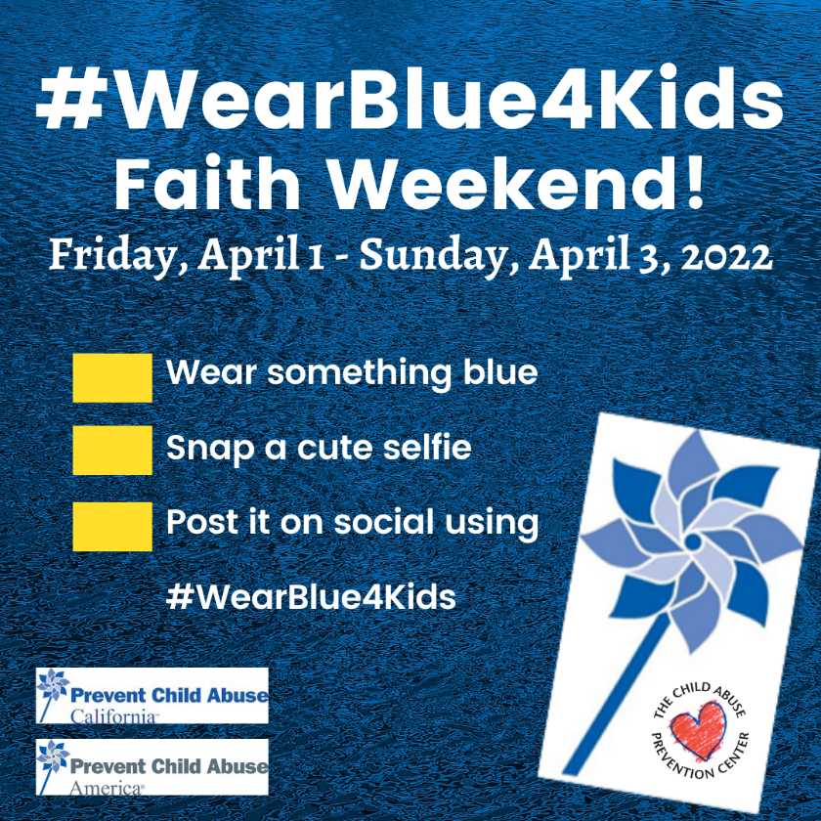

____________________________________________________________________________

**Zoom Backgrounds:**

Feel free to personalize and utilize these Zoom backgrounds on all of your virtual meetings.

____________________________________________________________________________

**Sample newsletter blurb**:

April is Child Abuse Prevention Month. All children deserve great childhoods, but sadly, it isn't always the reality. It's proven that kids who are raised in loving and supportive environments are more likely to grow up and help create secure, healthy communities and be more productive, prosperous adults. When raised in stable families, they do better academically, are shown to be more financially successful and contribute more to society. We all have a role to play in making sure that our community is the best place for children and families to thrive all year long, but especially during Child Abuse Prevention Month. Join efforts to become a Community in Unity and take action to prevent child abuse and promote strong, healthy families. Let’s make a big impact in our community. [Invite your members to take action or participate in activities and list those here.]

____________________________________________________________________________

**Social Media:**

Share your CAP Month activities on social media using these hashtags:

#Unite4Kids  
#WearBlue4Kids   
#CAPmonth  
#FaithForKids

Follow and share Wear Blue Weekend on social media.

____________________________________________________________________________

To learn more about The Child Abuse Prevention Center and the services we provide, please visit [www.thecapcenter.org](http://www.thecapcenter.org).

A special thanks to our funders who help make Child abuse Prevention Month a success!

